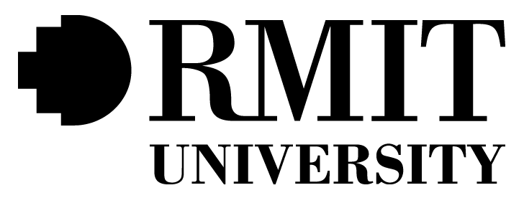

**CARER MANAGER PLUS ADMINISTRATION PORTAL**

**Management, Communication and Presentations Report**

**Start Date:**  **5 /10 /2022**

**Authors** **:** **Nadvi Karawita, s3823697**

**Jack Sydenham, s3841816**

**Stanley Chum, s3842670**

**William Hu, s3856557**

**Zhihao Zhong, s3756809**

**TABLE OF CONTENTS**

**1** **Group Presentation Slides …......................................................................... 4**

**2** **Team Member Time Sheets …........................................................................... 4**

**3** **Evidence of Teamwork**  **…................................................................................. 4**

* 1. Sample screenshots of daily communication through MS Teams, Discord, and Slack
  2. Meeting minutes
  3. Jira board screenshots with current backlog

**4** **Contribution Form ….......................................................................................... 5**

**5** **Analysis of ethical considerations …..............................................…. 5**

**6** **Analysis of learning outcomes based on various aspects …. 5**

1. Creative thinking
2. Critical thinking
3. Problem solving
4. Responsibility
5. Teamwork

**1** **Group Presentation Slides**



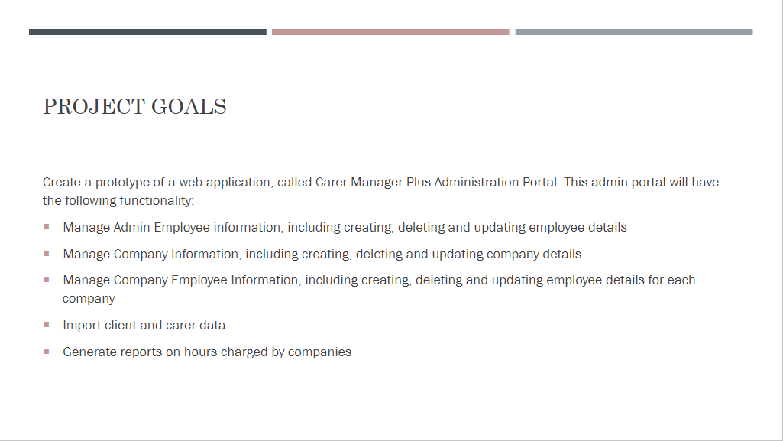

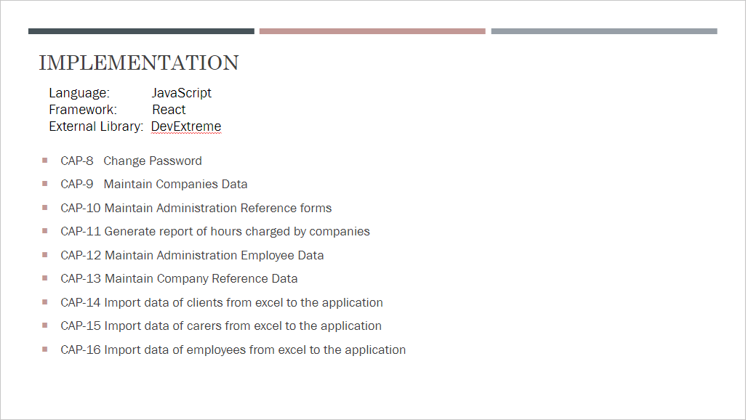

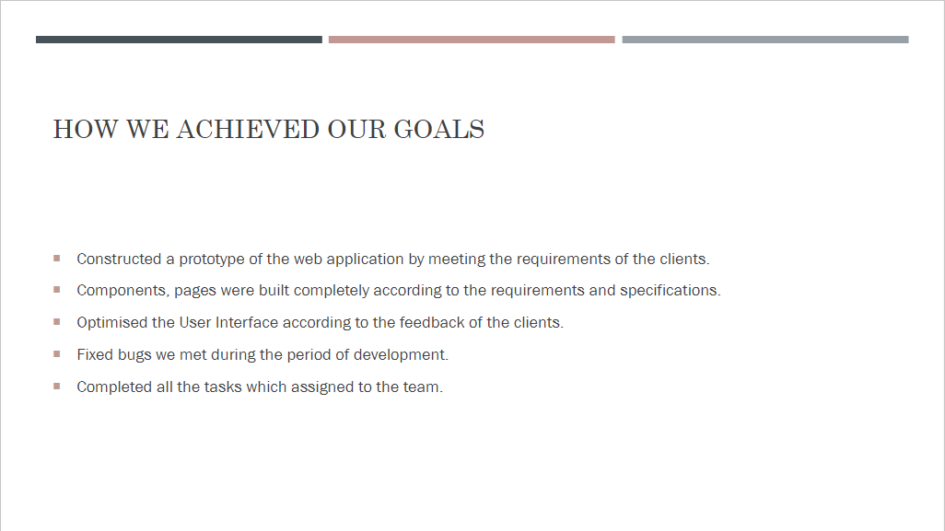

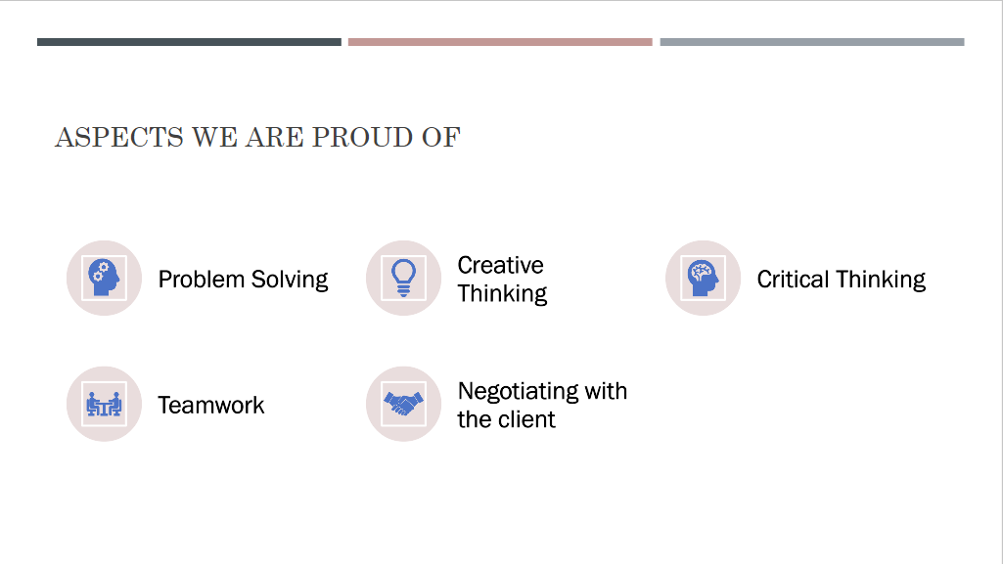

**2** **Team Member Time Sheets**

*Jack*

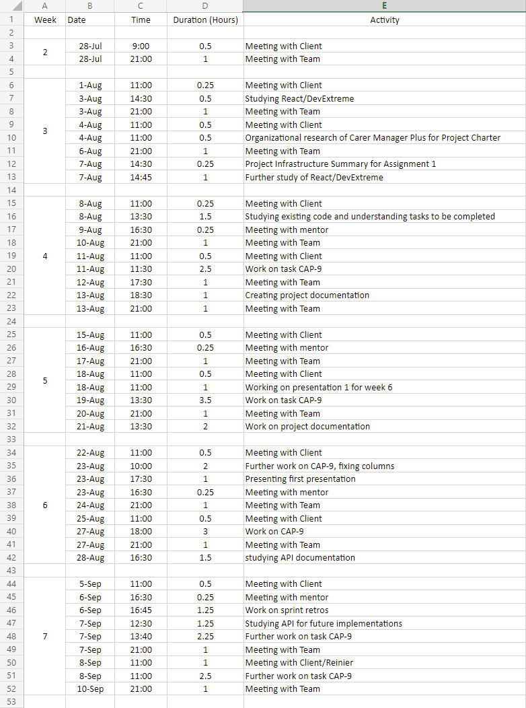

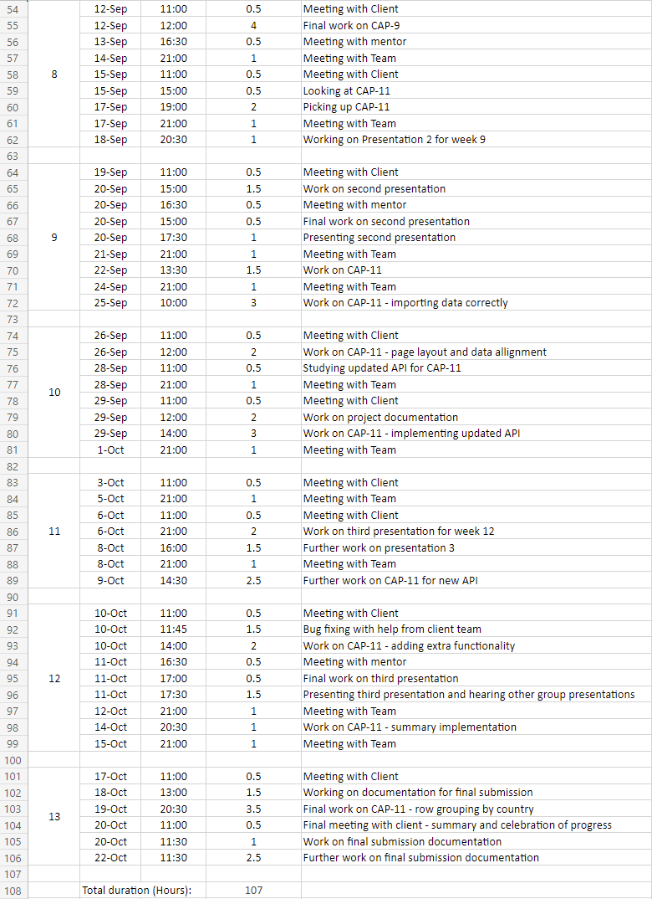

*Nadvi*

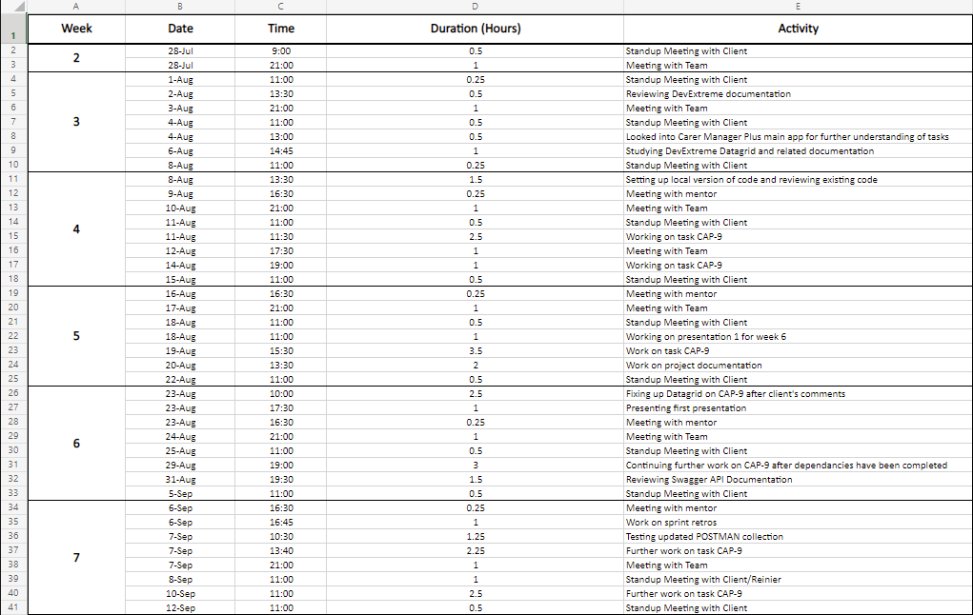

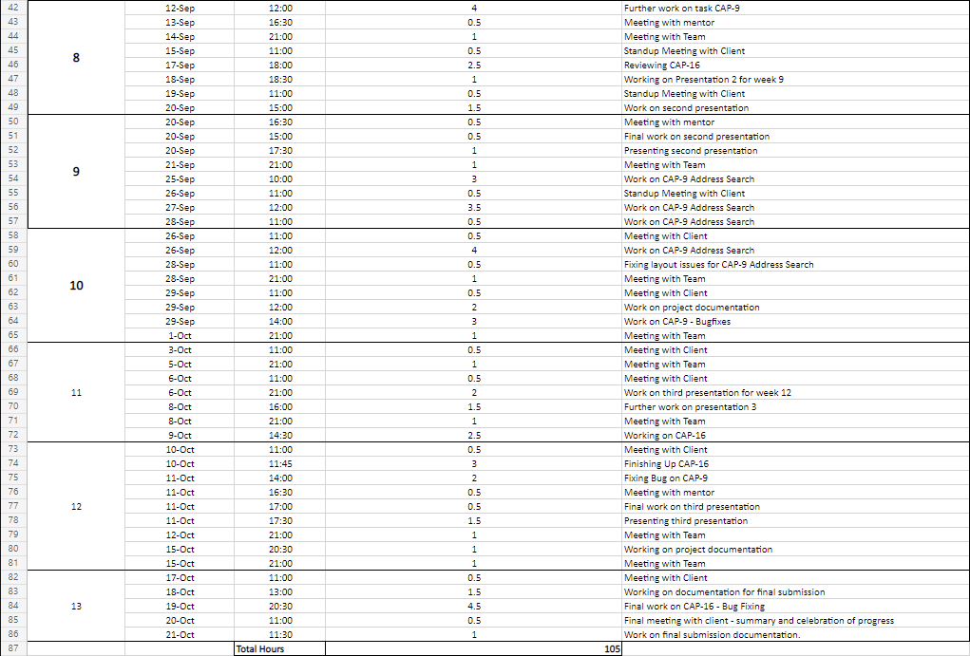

*Stanley*

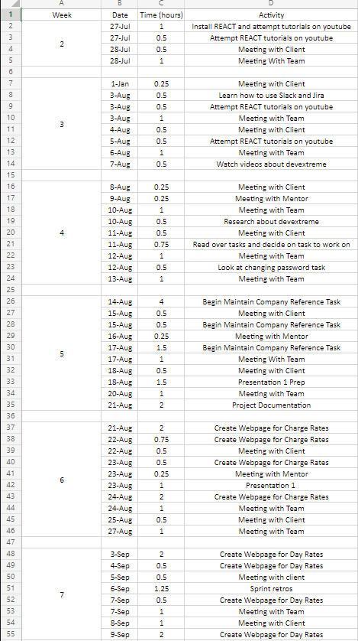

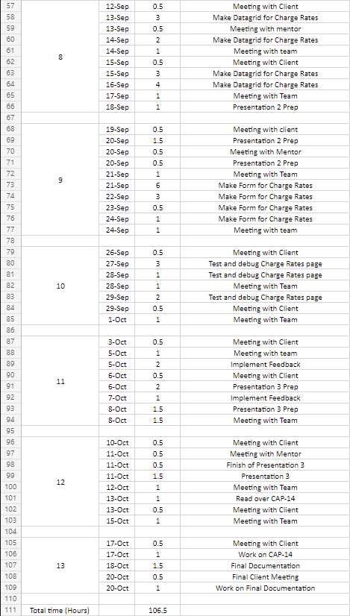

*William*

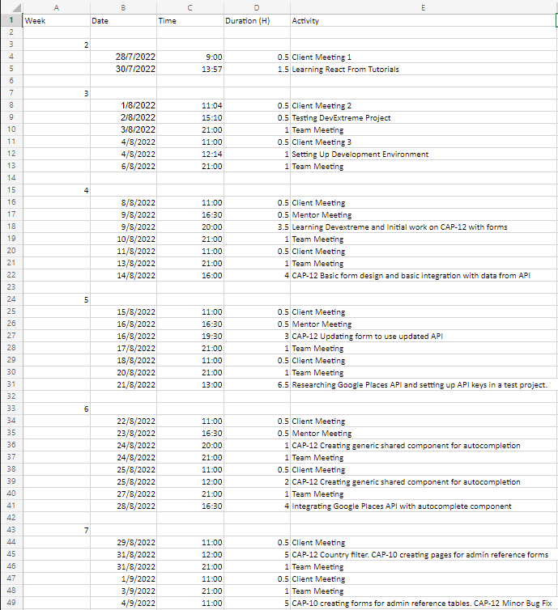

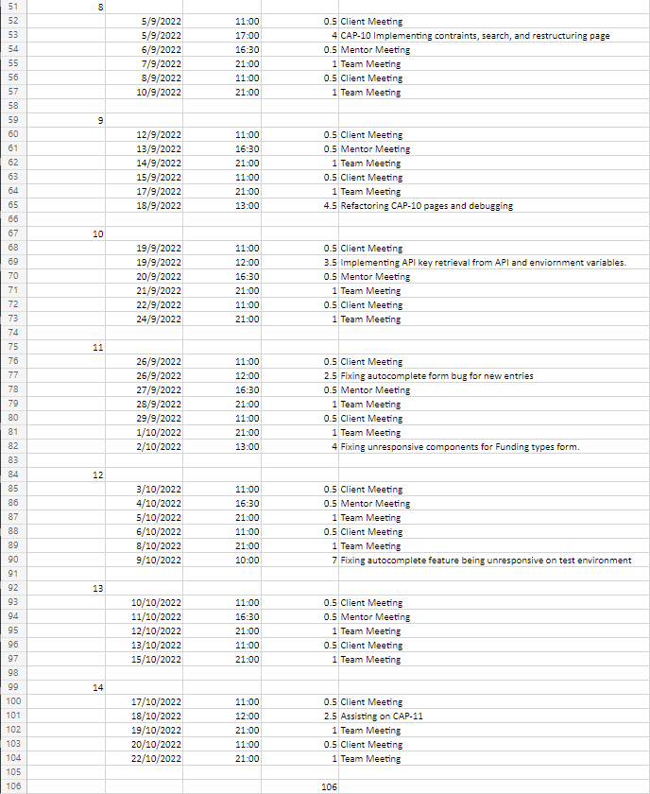

*Zhihao*

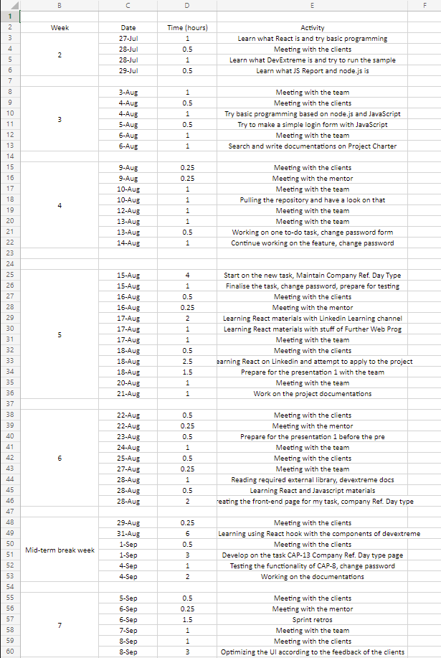

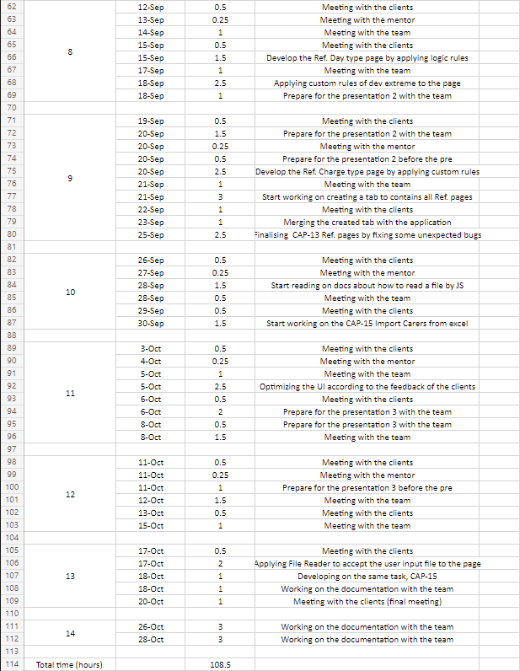

**3** **Evidence of Teamwork**

1. Sample screenshots of daily communication through MS Teams, Discord, and Slack

*MS Teams*

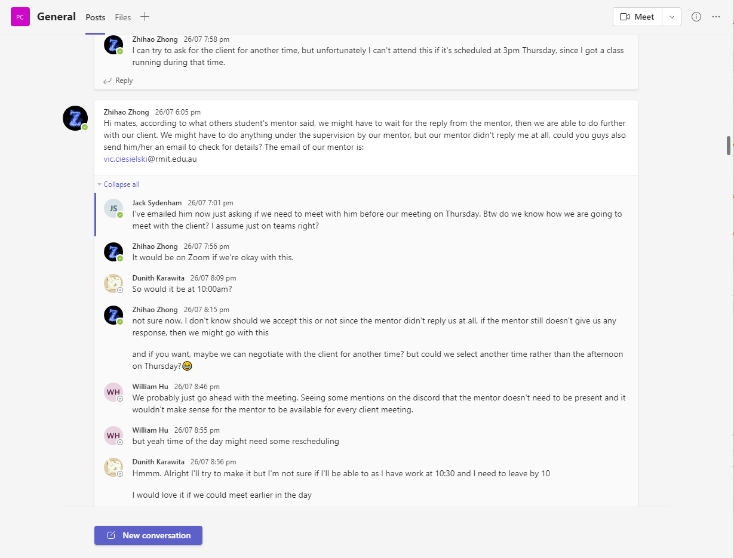

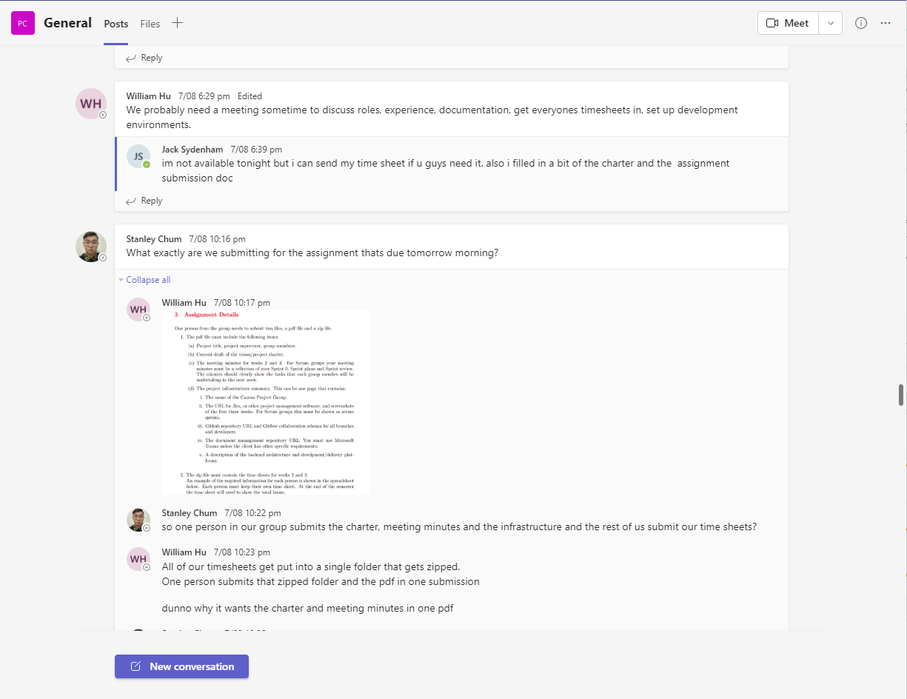

*Discord*

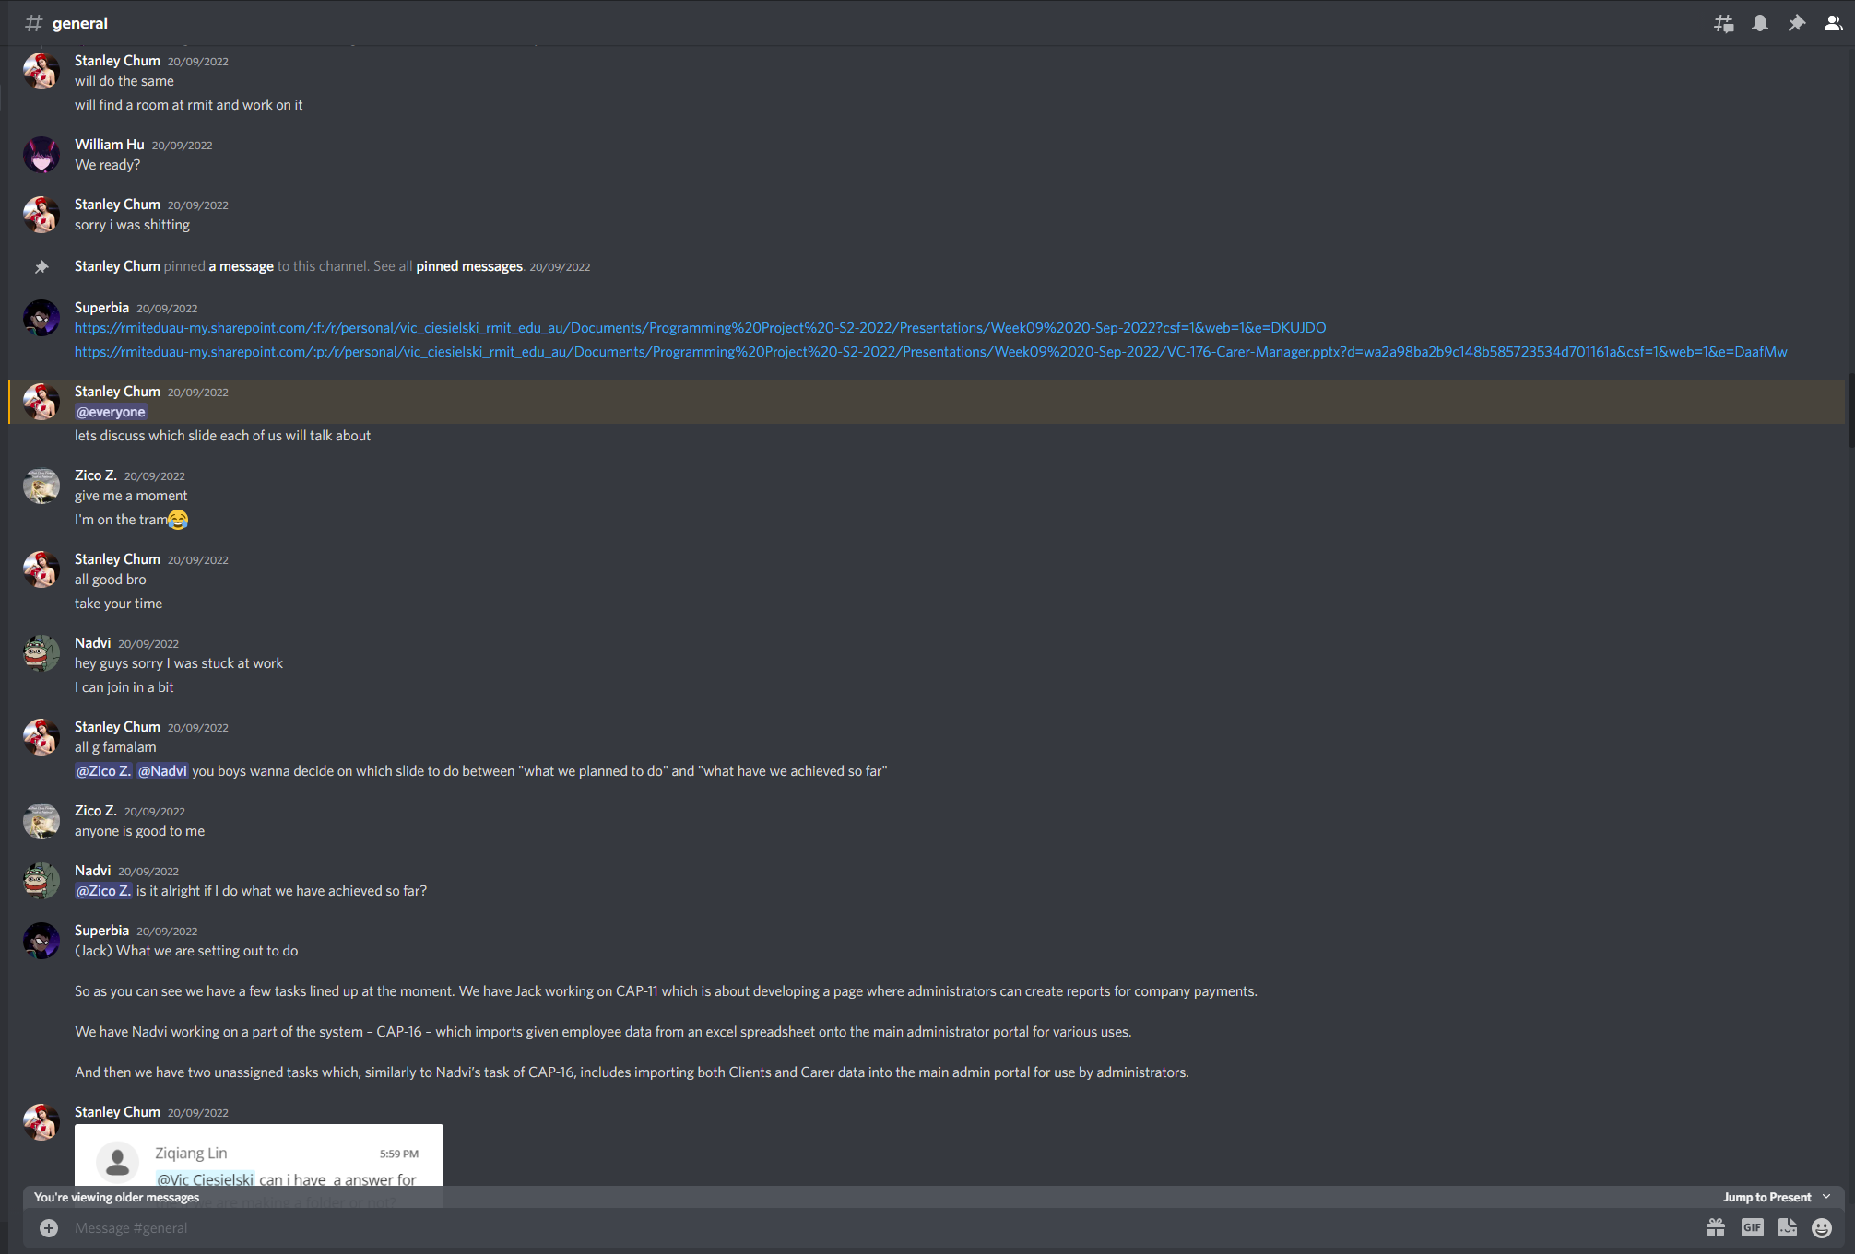

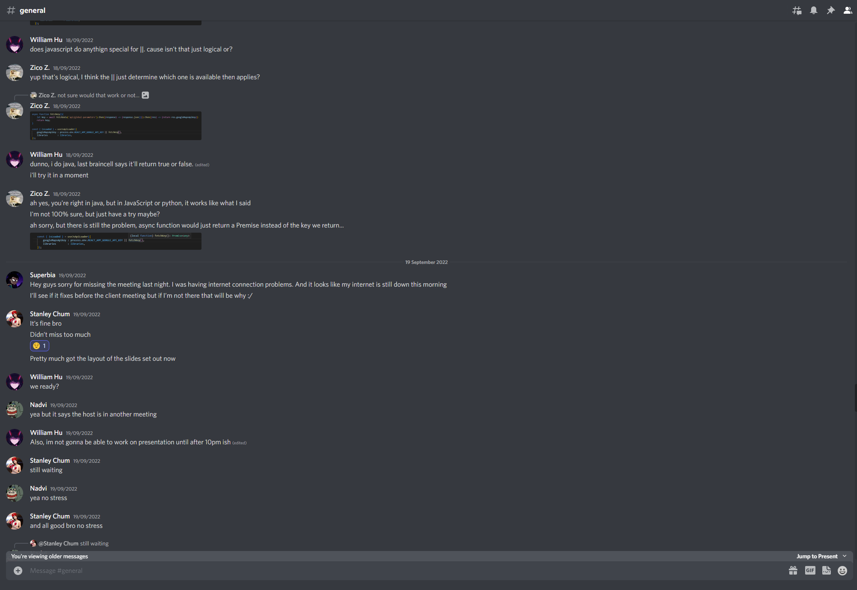

*Slack*

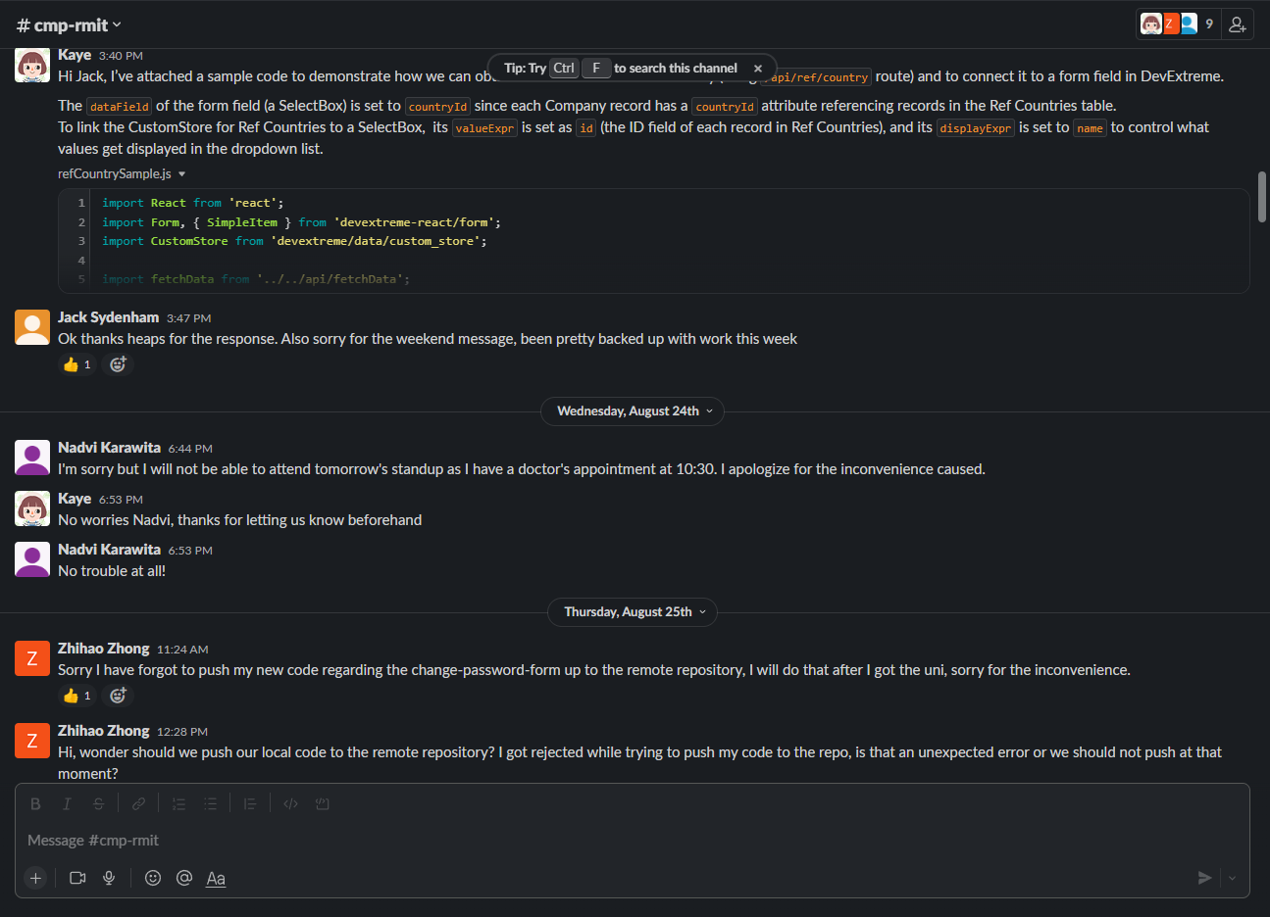

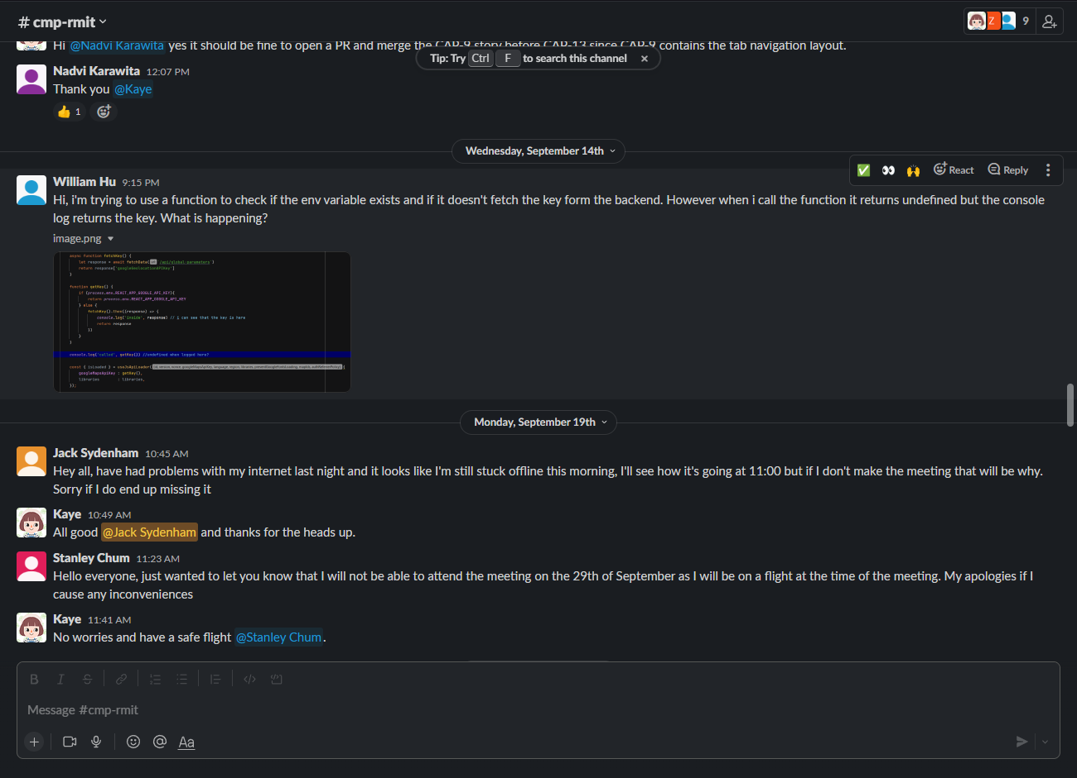

1. Meeting minutes
2. Jira board screenshots

*Current (final) Sprint and backlog*

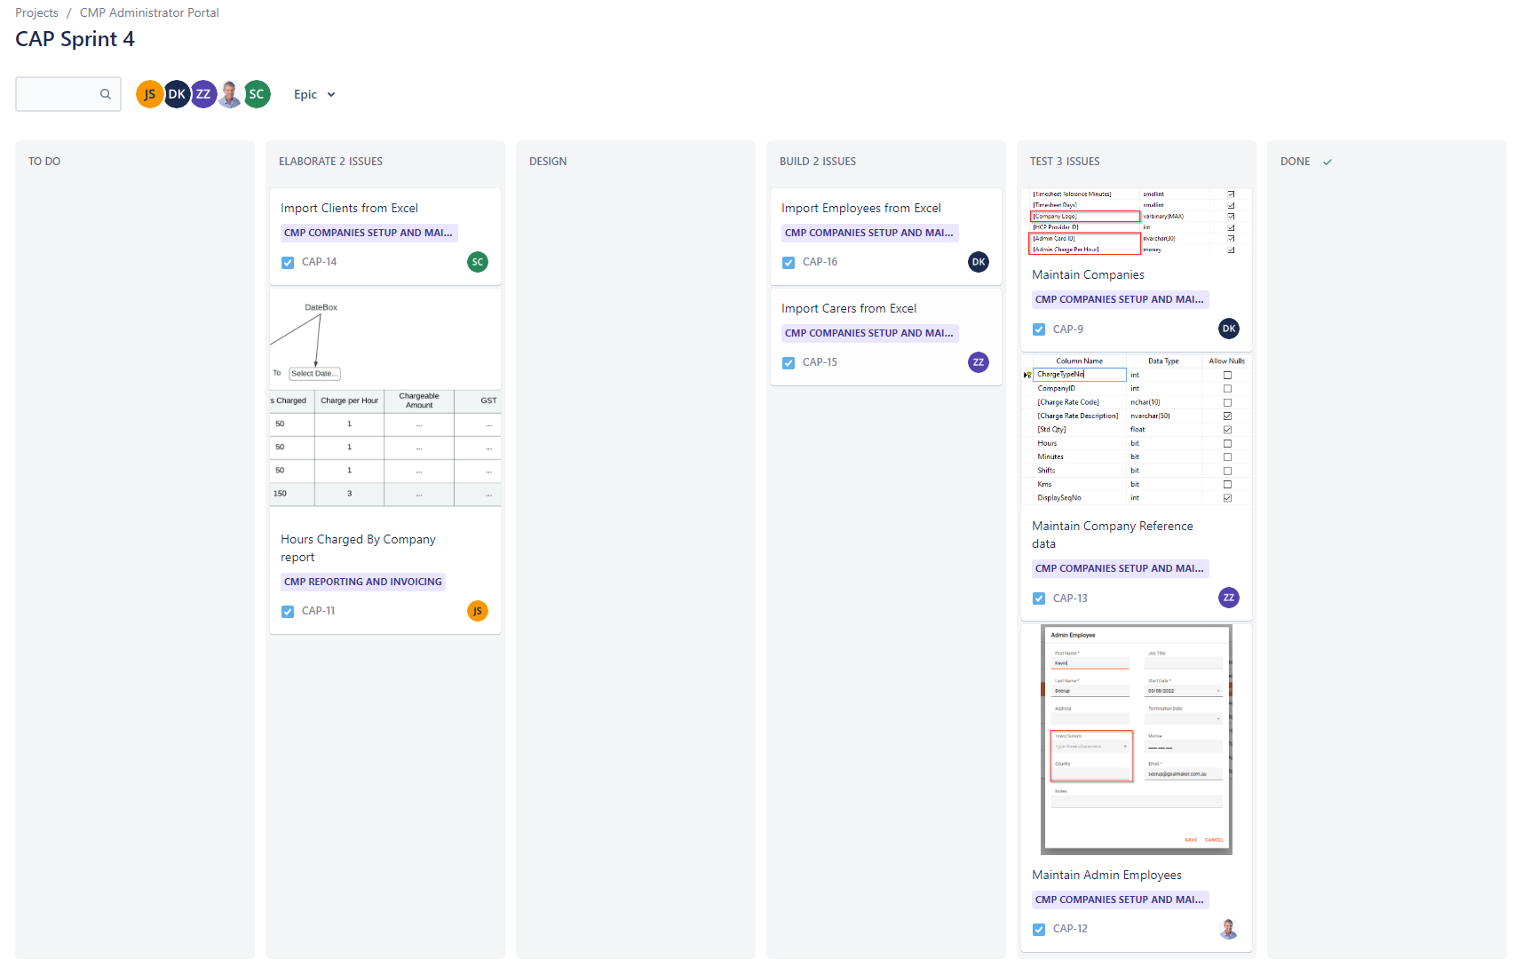

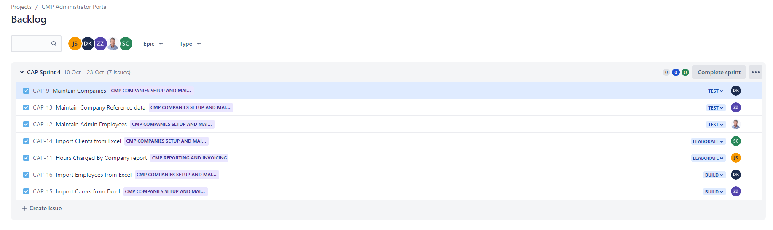

All task items worked on

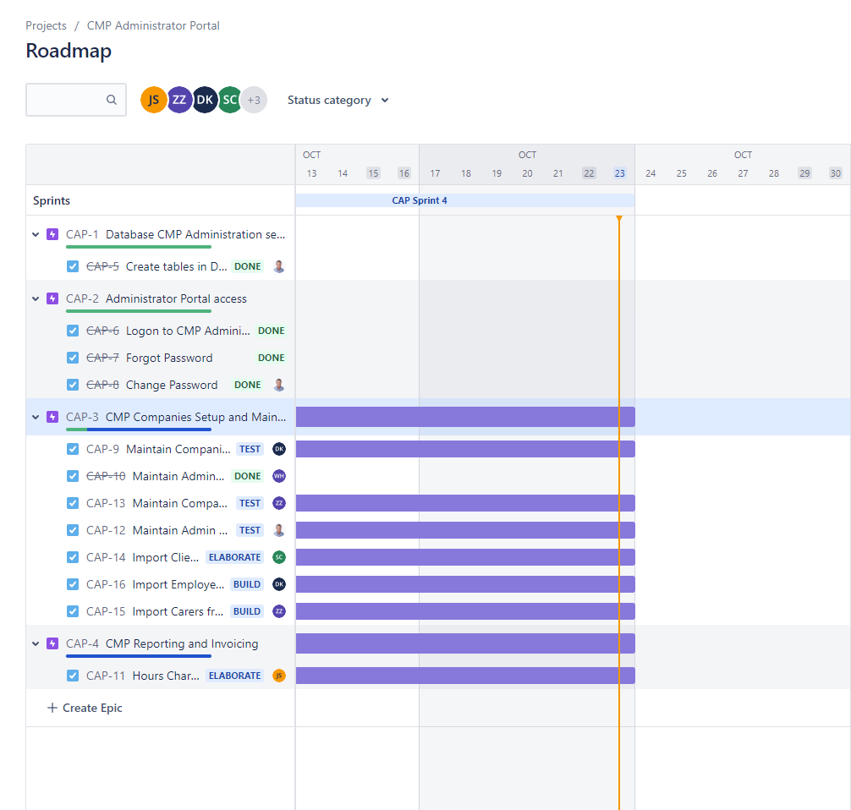

**4** **Contribution Form**

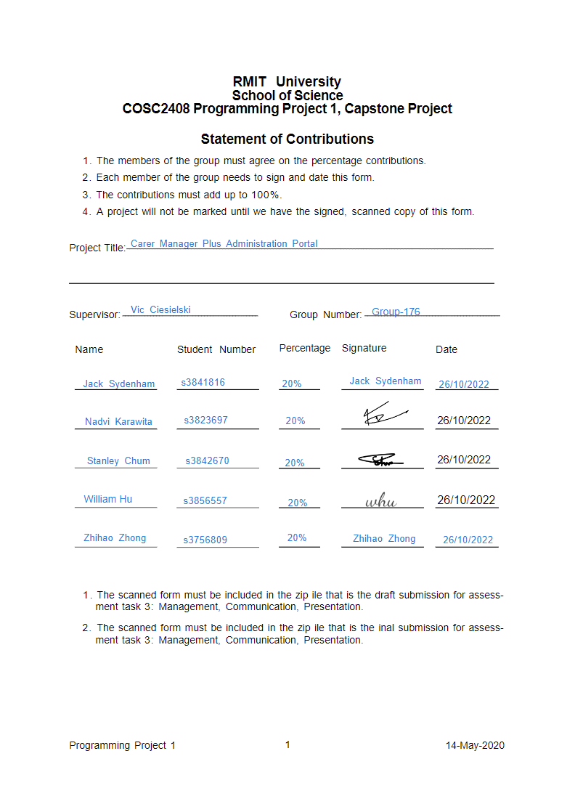

**5 Analysis of ethical considerations**

*The primacy of the public interest:*

The team adhered to all expected behaviours here, identifying those impacted by our work, raising potential legal conflicts with stakeholders, advising them if any objections were to arise.

*The enhancement of Quality of Life:*

The team recognised that the work that we were doing may play an important role in improving the life of people. We also understand that our work should aim to increase the feelings of personal satisfaction from stakeholders.

*Honesty:*

We remained honest throughout our project by not taking part in any bribery, distinguishing our personal opinions from our professional ones, giving realistic estimates of project progression, giving credit for work done by others, and not attempting to boost our own reputation at the expense of others.

*Competence:*

We aimed to provide products which match the needs of the stakeholders, while avoiding any misrepresentation of our skills as a project team. We respected the goals of our client, ensuring the tasks being taken on were relevant and pointing out when they were not.

*Professional Development:*

We continued to upgrade our skills throughout the project while increasing our awareness of issues affecting the profession and its relationship with the public, along with encourages other team members to continue their own professional development.

*Professionalism:*

We constantly took a calm and informed approach to completing our work professionally, ensuring all team members were engaging in this behaviour simultaneously. We avoided encouraging members to take any action which would lead to us breaking this code of professional conduct.

**6 Analysis of learning outcomes based on various aspects**

**Creative thinking:**

*Acquiring Competencies:*

As a group, we were able to successfully adapt to the particular domain in which we were placed, acquiring new skills through learning the JavaScript language, along with working with DevExtreme APIs in order to carry out development effectively with our client.

*Taking Risks:*

Many of our team members were assigned set tasks to work through throughout the project, though more often than not, we would incorporate new directions within our development, bringing new ideas to the table and producing additional project code even without strict guidelines to do so.

*Solving Problems:*

Through constant communication with both our client and amongst ourselves, we were able to develop logical plans to solve individual problems, while also considering all the possible downsides of each solution, providing us with a proper basis for selecting certain solutions over others.

*Embracing Contradictions:*

Alternate ideas were always considered by the team, totally embracing divergent perspectives to understand different outcomes and better understand what makes good ideas so positive for development.

*Innovative Thinking:*

In order to truly develop the given system which we were working on, new ideas had to be brought to the table. To do this successfully, our team constantly questioned our client with new ideas or uses for the system, making way for new knowledge to be shared with the client team.

*Connecting, Synthesizing, Transforming:*

Furthering our team’s innovative thinking, we had great success in connecting existing ideas, along with ideas that had been introduced to the client, synthesizing the collection of ideas presented into a single whole concept.

**Critical thinking:**

*Explanation of Issues:*

Using our Jira board, all relevant issues were very clearly laid out and understood by both the team and client. Each issue included a sufficient explanation, usually accompanied by images for further clarity and cohesiveness.

*Evidence:*

Multiple sources are always considered when taking new information into account. While the official DevExtreme and React documentation is usually considered primarily, other sources were always considered by the team to develop a comprehensive understanding of the subject being worked on.

*Influence of Context and Assumptions:*

Our team presented opinions and positions only on the basis of carefully evaluating the relevance of contexts of the positions which we were presenting, along with analysing our own and others’ assumptions about said positions.

*Student Position:*

The specific positions presented by the team were took the complexities of a given issue into account, while other team members’ points of view were constantly acknowledged in the context of each other's positions.

*Conclusions and Related Outcomes:*

The conclusions produced by the team were logically tied to a range of information provided, where opposing viewpoints were consistently considered, and outcomes related to these conclusions were clearly identified based on perspectives discussed.

**Problem solving:**

*Defining Problems:*

Our team was able to clearly identify problems, constructing clear and insightful statements defining said problems accompanied by evidence of relevant contextual factors.

*Identifying Strategies:*

More often than not, multiple approaches for solving individual problems were identified that apply to those problems’ contexts.

*Proposing Solutions:*

Solutions were proposed with comprehensive coverage of the problem being solved. These solutions were also sensitive to the problems contextual factors, along with the logical dimensions of the given problem.

*Evaluating Potential Solutions:*

Solutions were evaluated very insightfully, reviewing the history of the problem and taking logic/reasoning, along with the feasibility of the solution found, considering the impacts of the solution to ensure we make the correct decision as a team.

*Implementing Solutions:*

Our team implemented revised solutions in a manner which thoroughly addresses multiple contextual factors.

*Evaluating Outcomes:*

Results of a solution were reviewed relative to the problem with specific considerations laid out for further work which may be needed.

**Responsibility:**

*Own Contribution:*

As seen in our contribution form, team members contributed equally, completing all assigned work in a timely manner that remains thorough and comprehensive, leading to sufficient progression within the project. Team members also proactively look out for one another to ensure tasks are completed to a high standard.

*Self-Learning:*

Team members were able to set up realistic and appropriate goals, develop plans to independently take on tasks with a clear deadline in place, complete given tasks without monitoring, along with independently monitoring performance during the learning activity

*Acting Ethically:*

Our project was based more on the development of a private system, rather than the research of a field, and so ethical considerations were not highly present. We did however, have to consider the ethicalities of utilising other company data, ensuring that correct ethical perspectives were considered when storing the data of an external company and that said data was handled in an ethical manner.

**Teamwork:**

*Contributions to Team Meetings:*

All members worked to help in moving the project forward by offering alternative solutions wherever possible, along with articulating existing solutions or proposals to ensure effective progress.

*Facilitates the Contributions of Team Members:*

Team members were able to push other members to contribute, giving them a platform to voice their views, constructively building upon or bring the ideas of others together, creating a coherent whole. We also made it clear to team members who were not contributing as much, that they should speak up and voice their opinions.

*Individual Contributions Outside of Team Meetings:*

All members completed their assigned work to high standards with comprehensiveness, advancing the project sufficiently. Furthermore, team members often looked out for one another, ensuring that other team members were able to complete their work to a high standard as well, often offering help.

*Fosters Constructive Team Climate:*

The team supported a constructive team climate by treating each member with the utmost respect, being polite and constructive in communicating the progress of the project. We also held a high level of positivity, constantly encouraging each other to achieve the best result out of our work, and that our team was able to accomplish our goals successfully. Finally, team members were helpful, aiding and/or encouraging each other directly to help in reaching our goals.

*Responds to Conflict:*

We addressed all destructive conflict in a direct and constructive manner, resolving said conflicts in a way that strengthens overall team cohesiveness and effectiveness in the future.